# Laboratory 8

1. Questions
   1. Implement a linked list and perform following operations.
      1. Insert a node before and after a given node
      2. Delete a node before and after a given node
   2. Implement a linked list to create and print a binary tree.
2. Algorithm
3. Program

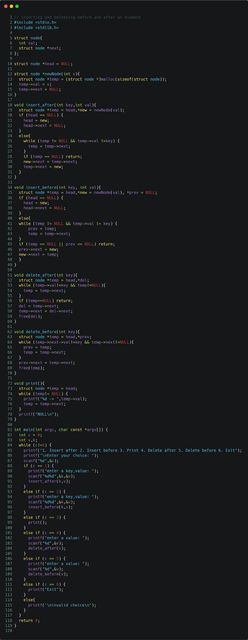

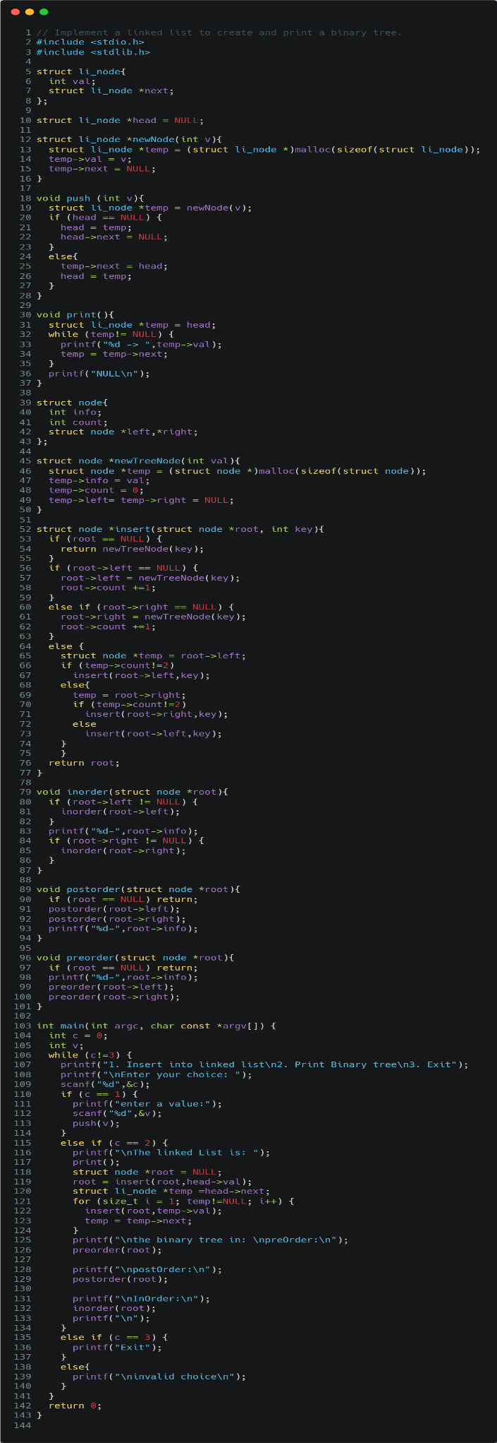

1. Presentation of Results

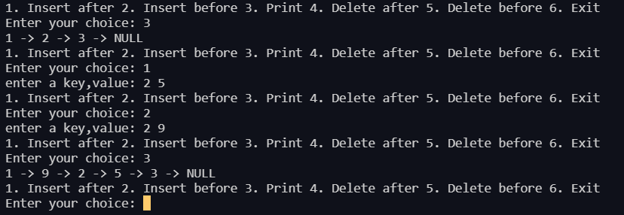

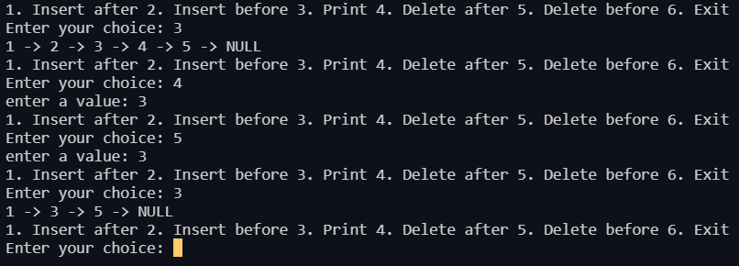

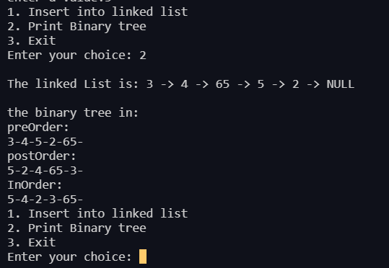

1. Conclusions